33. When 30 randomly selected customers left a convenience store, each was asked the number of items he or she purchased. Construct a frequency distribution (5 marks) for the data and construct a properly labelled histogram (4 marks), frequency polygon (2 marks), and cumulative frequency curve (Ogive) (3 marks) on the same graph provided below. Analyze the data (2 marks).
2 9 4 3 6 6 2 8 6 5 7 5 3 8 6 6 2 3 2 4 6 9 9 8 9 4 2 1 7 4
- Frequency distribution

Class Boundaries | Frequency/ Tally | Relative Frequency | Cumulative Frequency | Cumulative Relative Frequency
0.5 – 1.5 | 1 | 0.0333 | 1 | 0.0333
1.5 – 2.5 | 5 | 0.1667 | 6 | 0.2000
2.5 – 3.5 | 3 | 0.1000 | 9 | 0.3000
3.5 – 4.5 | 4 | 0.1333 | 13 | 0.4333
4.5 – 5.5 | 2 | 0.0667 | 15 | 0.5000
5.5 – 6.5 | 6 | 0.2000 | 21 | 0.7000
6.5 – 7.5 | 2 | 0.0667 | 23 | 0.7667
7.5 – 8.5 | 3 | 0.1000 | 26 | 0.8667
8.5 – 9.5 | 4 | 0.1333 | 30 | 1.000
Total | Σf = 30 | Σrf = 1 | 144 | Σcrf = 4.8

- Histogram

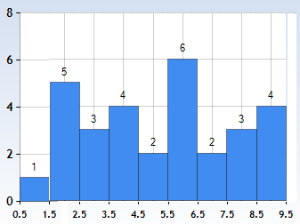

- Frequency polygon

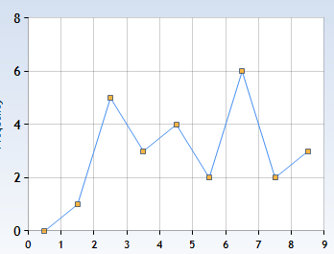
iv).
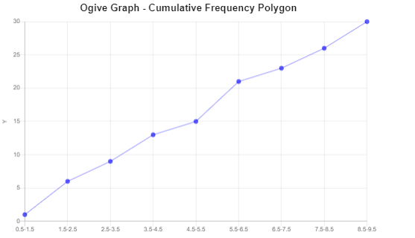

Based on the data provided, it can be noted that the number of items that each customer purchased varied, this could therefore be contributed by factors such as customer’s income status or even the tastes and preferences in general.
34. Construct a Pareto chart using the data below detailing the on cream for 40 different students. (5 Marks)
N | V | C | C | V | MCC | N | V | MCC | N
S | N | V | TT | MCC | RR | MCC | S | C | TT
C | N | RR | N | S | C | N | MCC | TT | MCC
C | TT | V | C | N | V | C | MCC | S | C

Ice-cream Flavour | Tally | Frequency | Relative frequency (%)
N - Neapolitan; | /////// | 8 | 42.5
V - Vanilla; | //// / | 6 | 75
C - Chocolate; | //// //// | 9 | 22.5
MCC - Mint Chocolate Chip; | //// // | 7 | 60
RR- Rocky Road; | // | 2 | 100
TT - Tiger Tail; | //// | 4 | 85
S - Strawberry | //// | 4 | 95
Total |  | 40

